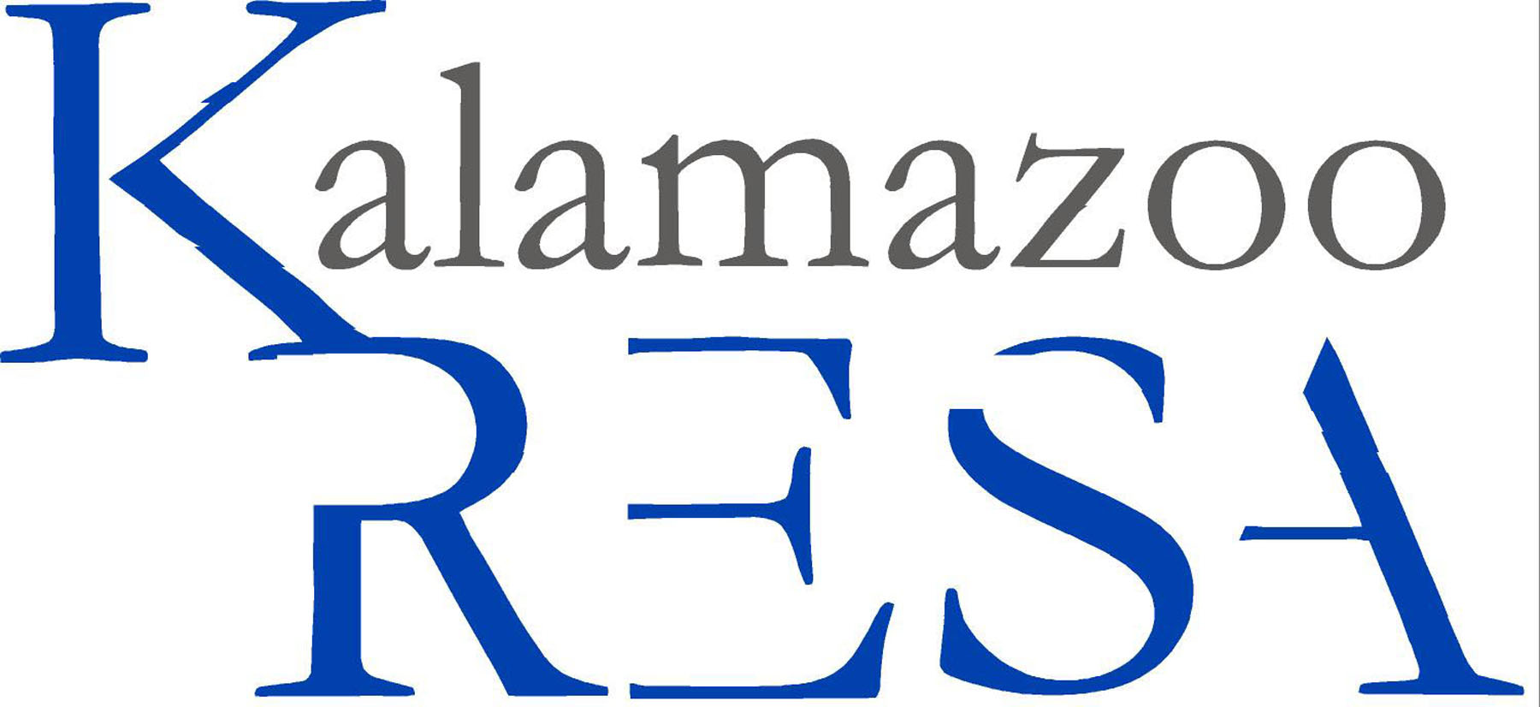
Kalamazoo Regional Educational Service Agency
Job Description

Job Title: Executive Assistant to the Superintendent
Reports To: Superintendent
FLSA Status: Non-Exempt
Prepared By: Human Resources
Approved By: N/A
Prepared Date: 08/2004
Last Revised Date: 10/2007

Summary:
Performs duties to meet the needs of the Superintendent and the Board of Education in the accomplishment of
their goals and in accordance with the agency’s mission of providing excellent service.

Essential Duties and Responsibilities:
- Assists with daily management and operation of the office
- Composes and proofs from draft form correspondence, reports, bulletins, memoranda and other publications
- Generates confidential reports for internal and external distribution throughout the year
- Fields and responds to requests from parents, political officials/leaders, local and regional superintendents, local
- board members and various community and regional and state leaders
- Communicates with clients (state, higher education offices, local district, Kalamazoo RESA, community, etc)
- Prepares for and finalizes arrangements for various meetings, programs and travel for the Superintendent, Board
- of Education and their district administrators
- Manages administrative functions (scheduling, meetings, minutes, coordination of calendars, preparation of reports, coordinate communications) of a specific program/function within the organization.
- Oversees financial recording and quarterly meeting arrangements for Kalamazoo County School Officers Association
- Updates and distributes Kalamazoo RESA directories of county programs and schools annually
- Coordinates the efforts and meetings of support personnel as necessary
- Maintains copiers and postage machines for staff; orders and stocks supplies
- Attends and takes minutes for regular staff meetings and school board meetings
- Regular and consistent attendance
- Other duties as assigned

Must have knowledge of and comply with the policies and procedures contained in the Kalamazoo RESA handbook.

Education and/or Experience:
Associates degree or its equivalent; three years related professional experience and/or training. High productivity
level and accuracy required. Computer software applications in word processing, spreadsheets, database,
presentation software and Internet.

Page 2 Job Title: Executive Assistant to the Superintendent

Certificates, License, Registration:
None specified.

Other Skill & Abilities:
- Interpersonal skills commensurate with serving executive level management
- Ability to communicate effectively including listening
- Keep administrator abreast of department activity
- Works in a team oriented fashion
- Ability to efficiently use computer and applicable software
- Ability to problem solve
- Ability to read, analyze and interpret data
- Ability to write reports, correspondence, policies and procedures
- Maintains confidentiality
- Displays willingness to support and make decisions with sound judgment in timely manner
- Adapts to frequent changes in the work environment
- Uses equipment and materials properly
- Practices safe work habits

Supervisory Responsibilities:
This job has no supervisory responsibilities

Physical Demands:
Reasonable accommodations may be made to enable individuals with disabilities to perform the essential
functions. The employee is frequently required to reach with arms and hands, stand, walk and sit. The employee
must frequently lift and/or move up to ten pounds and occasionally lift and/or move up to 25 pounds. Specific
vision abilities required by this job include close vision, depth perception and ability to adjust focus.

Work Environment:
The noise level in the work environment is generally quiet.

The employee shall remain free of any alcohol or nonprescribed controlled substance in the workplace throughout his/her employment in the District.

It is the policy of Kalamazoo Regional Educational Service Agency that no discriminating practices based on gender/sex, sexual orientation, race, religion, height, weight, color, age, national origin, disability or any other status covered by federal, state or local law be allowed during any program, activity, service or in employment. The following positions at Kalamazoo RESA have been designated to handle inquiries regarding the nondiscrimination policy. Human Resources Director, Tom Zahrt; Assistant Superintendents: Margaret McGlinchey & Laurie Montgomery. Contact information: 269-250-9200, 1819 E. Milham Avenue, Portage, MI 49002.

